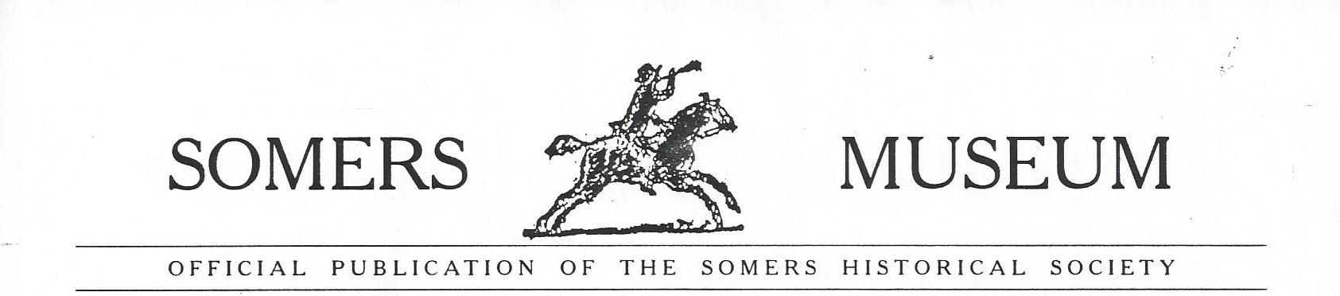
Late Winter/Spring 2015
Looking forward to Spring...
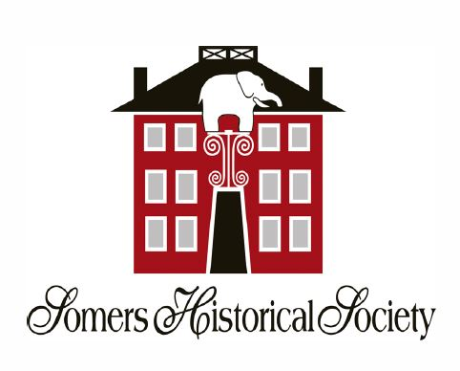
This year, 2015 marks the 180th anniversary of the formation of the Zoological Institute in the Elephant Hotel, a capital stock company arguably the most significant development in the history of the early American circus. The Zoological Institute was formed with capitalization of more than $300,000 with more than 100 investors. In today's monetary value that would equate to more than $8 million dollars.
The Elephant Hotel was given the designation of National Historic Landmark by the U.S. Secretary of the Interior in 2005, in large part, because of the formation of the Zoological Institute in this building.
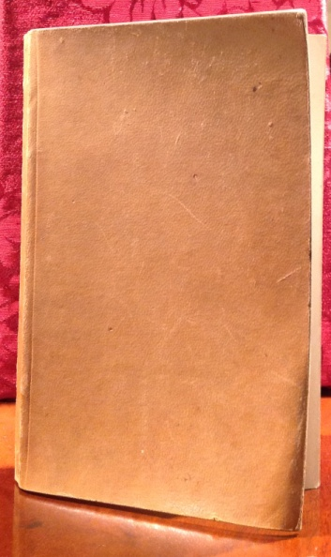
In commemoration of this historical event an article entitled "The Names in the Ledger: Harlequins, Horses and Howdahs" is being published in the winter issue of The Westchester Historian, the scholarly quarterly published by the Westchester County Historical Society. The article is written by former Somers resident and Society member Beverley Brigandi and based upon a menagerie ledger from our collection from that era.
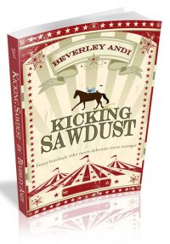 Beverley also wrote an historical romance under her pseudonym Beverley Andi, entitled Kicking Sawdust. The book is based on the same ledger and dedicated to Somers Historical Society, in part, because of our collections. Such an honor..thank you! The book, available early March from Wild Rose Press, is available as an electronic book AND as paperback. Autographed copies will be available through the Historical Society OR you can meet Bev herself in July when she visits for a special Society event. Look for detailed information in future mailings on our website and our Facebook page.
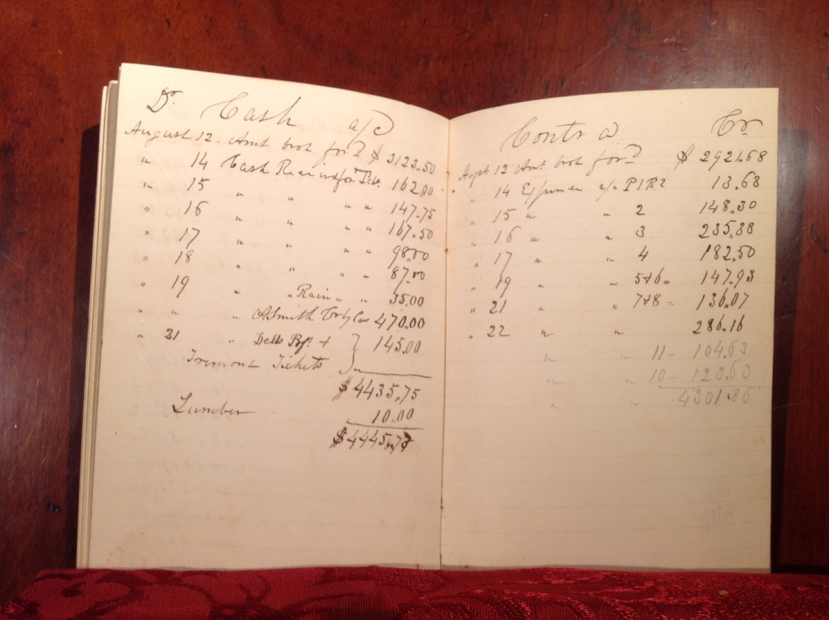
The following is a recent conversation with Beverley about her experiences in transcribing "Route Book #18" which served as the basis for her work.
What inspired you to transcribe the ledger?
The pristine ledger written by William Delavan in crisp, legible, black ink held the names of 32 performers listing their salary and weekly expenses. I was intrigued. Who were they? How were they related to Somers?
What inspired you then to write the paper? Like many, I knew little about the early circus. The research led me to uncover the negative attitude society placed on the young American circus. It exposed the difficulties women entertainers fought. Lastly, it put a spotlight on the amazing careers and the long lives of many of the performers.

Some, like the Wells sisters and Johnny Glenroy, went on to accomplished amazing equestrian feats. The youngest Wells sister, Amelia, became the first female clown in America.

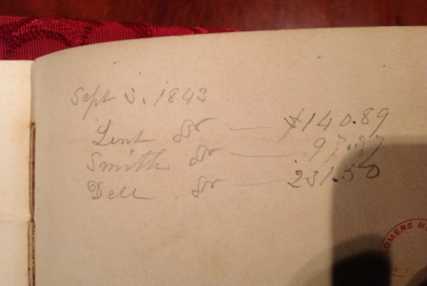
There was tragedy too. John Whittaker joined the Calvary and fought in the Civil War. While recovering from a wound in battle, he succumbed to a typhoid infection which ravaged the camp. His brother, Frank, fell on an icy track in New York City and was run over by a train. He lost an arm and later died from the complications. I needed to share their stories with others and to highlight the Somers Historical Society’s rich archive.

What inspired you to write the novel? How could I waste all that research? Kicking Sawdust is based on the real circus troupe who travelled by train along the eastern seaboard in the 1840’s. The names have been changed, though many of the characters in the story follow the outstanding careers of their real counterparts. It took a few years to begin putting flesh and bones on the names and deciding on a storyline. However, I did change the location from Boston to New York and the year from 1843 to1858. I needed the invention of the telegraph and sewing machine as well as the building of the Metropolitan Museum of art. My novel is a light romance thus my hero and heroine fall in love and, of course, live happily ever after in Westchester.

During the coming months, look for other events to commemorate the 180th anniversary of the formation is anniversary of the Zoological Institute in the Elephant Hotel. 2
Upcoming Events this Spring. Watch Facebook and Email for updates.
Saturday, March 21, 10am
Welcome Spring Organizational Meeting - Gardening at the Wright Reis Homestead - Join us as we plan our care of the homestead's three gardens, including the Somers Seed Lending Library and St. Luke's Church Food Pantry garden and hear from local gardening experts on how to care for this year's gardens and landscapes after the past winter.
April
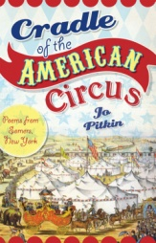
Saturday, April 18, online "Scenes in Somers, " an electronic exhibition on In conjunction with Town of Somers Earth Week Celebration
(Date TBD) Exhibition Opening Cradle of the American Circus In commemoration of the 180th anniversary of the formation of the Zoological Institute in the Elephant Hotel, World Circus Month & National Poetry Month. Exhibition based upon poetry from book by the same title.
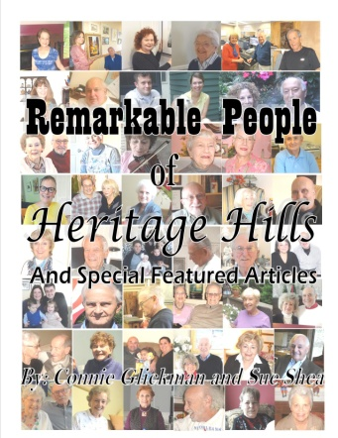
ANNUAL MEETING - Sunday, May 31, 2pm at Mt. Zion Church
Keep an eye out for "Remarkable People of Heritage Hills," a soft cover book being released in early summer which is being co-authored by member Constance Glickman with Heritage Hills resident Sue Shea.. Pre-publication orders can be mailed directly to them at RPHH, P.O. Box 5 Somers, NY 10589. Pre-publication price is $15, check payable to SHS earmarked RPHH. Some of the "remarkable people" featured in the book will be present at a private book launch reception later this year. Society members in good standing will be among those invited.
************************************************************************************************************* Look back... A wrap-up for our fiscal year, 2013-14 was distributed at our annual meeting and is too lengthy for inclusion here. For a copy, please call Society offices at (914)277-4977.
COLLECTIONS UPDATE - One of our missions is that of collecting photographs, papers and other objects related to Somers history to add to our collections. Please remember the Society's archives as you do your spring cleaning!
If you would like to assist with the care of a specific item in the collections, consider the Adopt-an-Artifact program of the Junior Historians. In the program, you select an artifact and donate any amount of money towards its restoration. The Junior Historians work with the Collections Committee on following through to the project's completion. In return, you receive an "adoption certificate" and recognition for your donation and the students learn about conservation practices. Contact somershistoricalsoc@yahoo.com or in Society offices (914)277-4977 for more information or if you would like to be involved with this program. Special thanks to those in the "first class year" of donors!
3
Adopt - An - Artifact Donors 2013-2014

Antiquarian Poetry Book Collection belonging to William Wright - Jo Pitkin, poet
Antique Bicycles belonging to Caroline & Walter Reis - Somers Girl Scout Troop #2968
Blue Taffeta Dress from Seymour Collection of Somers Historical Society - Kathleen Shelter, Duanne Simon, Somers Girl Scout Troop #2968
Botanical Watercolor by Caroline Wright Reis - Somers Newcomers & Neighbors Club
Bridle belonging to Caroline Wright Reis -Jan Antonucci in memory of George Lenfest, Joanne Jantos, Jeff & Grace Zimmermann in honor of Madeline Zimmermann & her horse Bandit
Gate Leg Farm Table - Sharon Panzarino in honor of Erika Panzarino
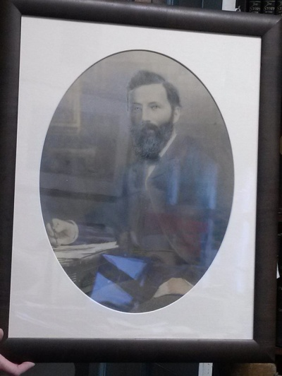
Photographic Portrait of Samuel Wright -Arnie & Elsie Guyot, Cassandra Panzarino, The Wesley family in honor of Murray & Edith Oringer, Sanjivani Bakare in memory of Mickey Oliver
Photographic Portrait of Samuel Wright
Photograph of William Wright's 50th Anniversary Class Reunion, Princeton Class of 1860 - Arnie & Elsie Guyot
Lap Chalk Board with Writing by Caroline Wright Reis - Somers Girl Scout Troop #2968
Side Saddle - Jim Boniello
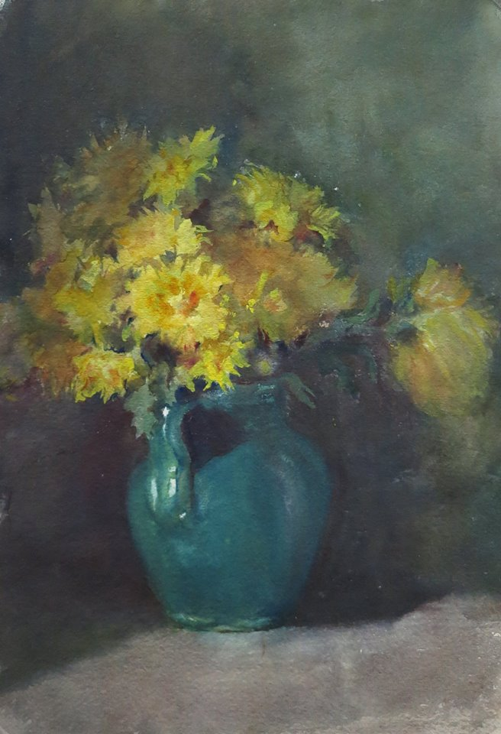
Sleigh - Denise Donahue, Eddie Gerrity, Steven Procario, Somers Girl Scout Troop #2968, Mark Fuchs for Danielle Semenza

RECENT ACQUISITIONS:
Business ledgers of John Sunderland, circa 1800. (John Sunderland was a millwright who lived and built two homes in the Somers Hamlet, a National Register Site, in what is now Dr. Ranani's medical practice.)
Photographs, letters and other documents related to restoration of the statue of Old Bet
Botanical Watercolor by Caroline Wright Reis
China belonging to Anna Brown Turk, circa 1850. (Anna Brown Turk was the wife of William Dean Marshall, grandson of William Marshall, Sr., the builder of the Wright Reis Homestead and a former Supervisor of the Town of Somers. )
Vintage elephant headdress, circa 1920
Photographs of Somers Circus Day Parade - 1966
4

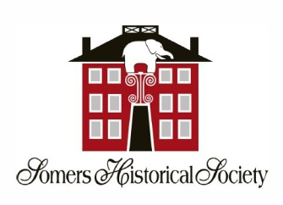
Adults looking to volunteer?
Students looking for community service hours?
Look no further. Opportunities abound with the Society!
Here are a few suggestions....
- serve as docent/volunteer at museum and town landmarks - brief training sessions required
- assist in gardening/planters at Elephant Hotel, gardens at Wright Reis Homestead
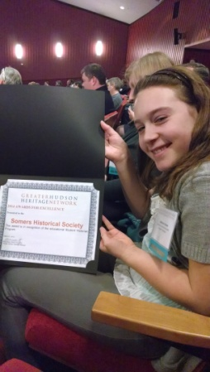
- assist with "Voices of the Hudson Valley" oral history project
- work with Society Collections Committee and Student Historians to inventory, help create exhibits, identify & interpret artifacts, photographs, documents, etc. for Somers Historical Society, as well as for the Wright Reis collections owned by the Town of Somers
- assist with social media, online collections and general IT projects
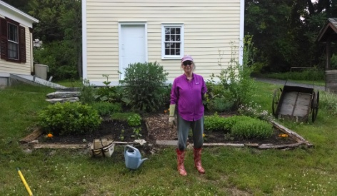

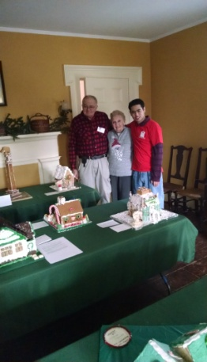
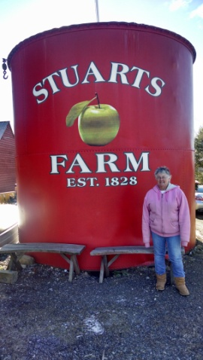
Thank you to the following volunteers who helped in numerous ways with many activities throughout the year. Philip Merkel, Athena & Missy Traver, Erika Panzarino, Joe & Melanie Darensod, Ric & Polly Peace, Vicki DiSanto, Val Herman, Peggy Weissgerber, Jeff Zimmermann, Gabriel Osorio, Madeline Zimmermann, Melanie Firestone, Jane & Roy Pepino, Arnie & Elsie Guyot, Susan & Bill Slyman, Jerry Billingsley, De Wittmann, Jo Pitkin, Shilo Kennedy, Eddie & John Fiscella, Steve Chetcuti, Patrice Lovell, Steve & Mary Delzio!
Also thank you to the following businesses: Katonah Nursery and Lawton Adams for contributions to the St. Luke's Church Food Pantry garden established by Somers Historical Society and Somers Seed Lending Library, along with church members; Somers 202 Restaurant, Somerfields , Stuarts Farm and Trader Joe's for donating gift certificates and refreshments for Gingerbread Festival 2014!
Newsletter published by Somers Historical Society Publications Committee- Rose Fiscella, Jo Pitkin, Grace Zimmermann 5
The Zoological Institute

Study royal tigers, jaguars, jackals.
Don't learn their real Latin names,
genus plus specific epithet that pin
down their colors, homes or finders.
Don't read Baron Georges Cuvier,
Lamarck, Natural History by Buffon.

Stand inside a room, barn or tent.
Eye the never-before-seen cargo
sought and bought by neighbors,
unschooled American naturalists
who merge and split stock shares
in hyenas, zebras, polar bears.

Hold out a trembling hand. Touch.
Thumb dewlap and antler velvet.
Finger a peacock's jeweled eye tail.
Paw spotted hid of flickering light.
Seek the violet ostrich swimming
in its cloudy, inviolable oval egg.

Witness enemies who once warred
at the darkening riverbank
now gather together in twilight
where the possible breathes.

Reprinted with permission of Jo Pitkin, author of Cradle of the American Circus; Poems from Somers, NY, in commemoration of the 180th anniversary of the formation of the Zoological Institute in the Elephant Hotel. This book is available locally at The Mexican Shack and in the Elephant Hotel and online at History Press.

